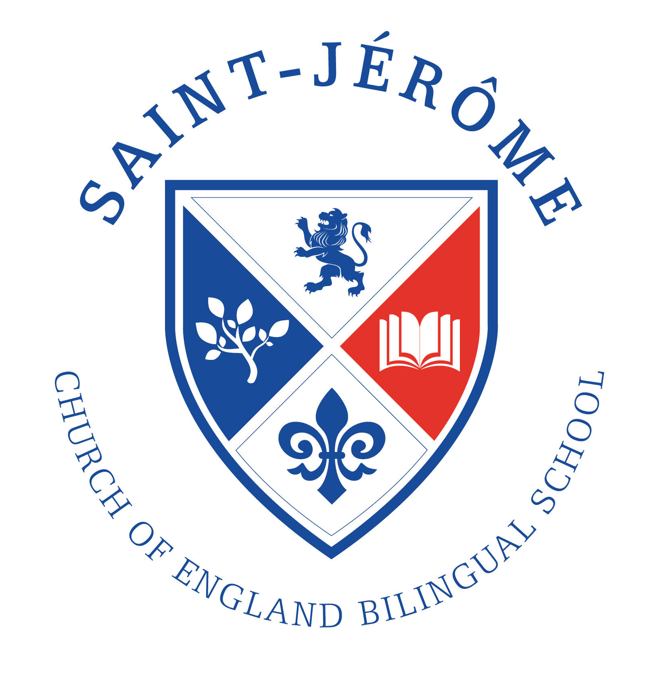 | ADMISSION POLICY  For admission to Reception in September 2016
St Jérôme’s is a new Church of England primary free school, which proposes to open in September 2016. When full, the school will provide 420 places for children between the ages of 4-11. The Church of England character underpins all that happens in the school. However this does not mean that all our pupils come from a Christian background, and children from all faiths and those with none are warmly welcome to apply.

St Jérôme’s is a bilingual school. This means that all the children who attend will spend some time learning in French as well as learning in English. The core subjects will be taught in English and other subjects will be taught in French and English or in French. Children do not need to be able to speak French before they join the school.

Published Admissions Number: There are 60 places available in Reception each year.
Oversubscription Criteria
In the event that there are more applicants than places available, and after the admission of pupils with an Education, Health and Care plan or a Statement of Special Educational Needs naming the school, priority for admission places will be allocated on the basis of the following oversubscription criteria which will be applied in this order:
- Children who are Looked After or Previously Looked After and those who immediately after being looked after became subject to adoption, a child arrangement order, or special guardianship order.
- The children of the two founders of the school who have been granted this provision by the Secretary of State for Education.
- Up to 12 places in each year group are designated as Foundation places.
- Children with a Sibling on roll when they apply [applies from Sept 2017].
- The remaining places are designated as Open places.
Foundation Places
You can apply for a Foundation Place if you are a committed member of an Anglican Church or of a Church or Chapel of other Christian denominations defined as those identified with ‘Churches Together in Britain and Ireland’ or who are a member of the Evangelical Alliance.
In this context, ‘committed’ is defined as attendance by a child and parent/ guardian/ carer at a Church at least twice a month for a minimum period of two years immediately before the date of application. Parents wishing to apply for a Foundation place should fill out a Supplementary Information Form which includes a signature from a Minister to confirm regular attendance. The only exception will be those families who have recently moved and can provide a letter from a Minister to confirm committed attendance at a different church.
Applicants for Foundation places who cannot be allocated a place under this criterion will be considered for a Sibling Place criterion 4 and an Open Place criterion 5.
Sibling
‘Sibling’ refers to brother or sister, half brother or sister, adopted brother or sister, step brother or sister, foster brother or sister or the child of the parent/carer’s partner where the child for whom the place is sought is living in the same family unit at the same address as the sibling. A sibling relation does not apply when the child currently on roll will leave the school before the sibling starts.

Tie-breaker
Distance will be used as the first ‘tie-breaker’ if two or more applicants are equally qualified for a place within the oversubscription criteria 3, 4 and 5.
Distance is measured in a straight line from home to school, using a computerised mapping system based on ordnance survey data. The journey is measured in a straight line from the unique address point for the applicants Permanent Residence to centre point for the school site. This must be the address where the parent and child normally live and they must be living there on the closing date for receipt of application.
The location of the school’s site is 120 -138 Station Road, Harrow HA1 2QB Easting 515669 Northing 188706
Home address
The home address is where a child normally lives. Where a child lives with parents with shared parental responsibility, each for part of a week, the address where the child lives is determined using a joint declaration from the parents stating the pattern of residence. If a child’s residence is split equally between both parents, then parents will be asked to determine which residential address should be used for the purpose of admission to school. If no joint declaration is received where the residence is split equally by the closing date for applications, the home address will be taken as the address where the child is registered with the doctor. If the residence is not split equally between both parents then the address used will be the address where the child spends the majority of the school week.
In cases where applicants live equidistant from the school and places cannot be offered to both children, the available place will be allocated using a random selection.
How to apply
St Jérôme Church of England Bilingual School is not part of the co-ordinated admissions process in 2015/6 because it is a new school. This means that parents should apply direct to the school and an application to St Jérôme Church of England Bilingual School is in addition to applications made on the Common Application Form.
All applicants should complete an application form. Any applicant wishing to apply for a Foundation place should also complete a Supplementary Information Form (SIF). Both forms are available from the school office or on the school website www.stjeromebilingual.org. Applications should be sent to the school office by email or by post. If you are posting an application we recommend that you retain proof of postage.
The closing date for applications is midnight on 15 January 2016.

We will inform parents on 18 April 2016 about the outcome of their application to St Jérôme Church of England Bilingual School. The local authority will inform parents on the same date about the outcome of applications made through the common application process. Any parents who are offered a place at two schools will have until 3 May 2016 to decide which place to accept.
Twins and other multiple-birth children
In cases where only one place is available and twins or multiple-birth children tie for the last available place, then both or all will be offered a place even if this exceeds the planned admission number.
Where one twin has an Education, Health and Care plan or a Statement of Special Educational Needs that names the school, the other twin will be treated as having a sibling link for that academic year.
Pupils with a Statement Of SEN or an EHCP
The admission of pupils with a statement of Special Educational Needs is dealt with by a completely separate procedure. If your child has a Statement of SEN or an Education Health and Care Plan you must contact your local authority SEN officer.
Reception Year Deferred Entry

Applicants may defer entry to school up until statutory school age i.e. the first day of term following the child’s fifth birthday. Application is made in the usual way and then the deferral is requested. The place will then be held until the first day of the spring or summer term as applicable. Applicants may also request that their child attend part-time until statutory school age is reached. Entry may not be deferred beyond statutory school age or beyond the year of application. Applicants whose children have birthdays in the summer term should be aware that, if they wish to defer, they will need to apply for a Year 1 place for the following September and if the school is oversubscribed they are very unlikely to obtain a place.

Waiting List
If St Jérôme Church of England Bilingual School cannot offer a place you will be offered the opportunity of placing your child’s name on the waiting list. This waiting list will be maintained by the Academy Trust strictly in the order of the oversubscription criteria and not in the order in which the applications are received. This means that the list will be reordered when a new applicant is placed on the list.
Appeals
Parents have the right to appeal to an Independent Appeals Panel. They must notify the Academy Trust within 20 working days of the refusal of a place and details of how to appeal will be given at the time of refusal. The Academy Trust should be contacted at St Jérôme Church of England Bilingual School, London Diocesan Board for Schools, London Diocesan House, 36 Causton Street, London SW1P 4AU.
Withdrawal of Places
If the school and/or Academy Trust are given false information, the Academy Trust reserves the right to withdraw the offer of a place to the child at any time. Confirmation of address and other relevant proofs may be requested.
In-Year Admissions
Applications for In-Year admissions are made in the same way as those made during the normal admissions round. If a place is available and there is no waiting list then the local authority will communicate the Governing Body’s offer of a place to the family. If more applications are received than there are places available then applications will be placed on the waiting list and ranked by the Governing Body in accordance with the oversubscription criteria.
Fair Access
The school is committed to taking its fair share of children who are vulnerable and/or hard to place, as set out in locally agreed protocols. Accordingly, outside the normal admissions round the governing body is empowered to give absolute priority to a child where admission is requested under any local protocol that has been agreed by the Governing Body for the current school year. The Governing Body has this power even when admitting the child would mean exceeding the published admission number.

Within the meaning of paragraph 1.7 of the School Admissions Code published on 1 February 2012.
The school has two Founders who are parents. The Founders provided the original inspiration for the school and have worked tirelessly to bring the school to fruition. This criterion applies to the children of these Founders.
‘Sibling’ refers to brother or sister, half brother or sister, adopted brother or sister, step brother or sister, foster brother or sister or the child of the parent/carer’s partner where the child for whom the place is sought is living in the same family unit at the same address as the sibling. A sibling relation does not apply when the child currently on roll will leave the school before the sibling starts.
The distance that the child lives from the school is used to prioritise children within this criterion, see tie-breaker information below for details

